http://merimack.freeshell.org/WM102/helloworld.html

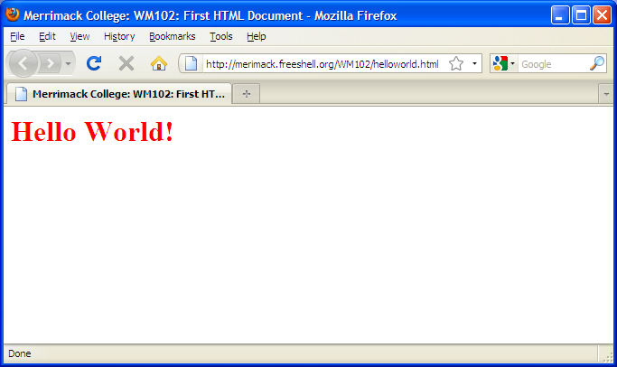

The source code:

<html>
<!--
Comment: The html element identifies the document as an html document. Here you see it in its simplest form.
-->

<head>
<!--
Comment: The Head of a document includes information that is read, interpretted, and not necessarily displayed by the browser.
-->

<title>Merrimack College: WM102: First HTML Document</title>
<!--
Comment: The Title indicates text that will be used to label the browser window and/or tab. It is also as the default label when a page is bookmarked by a visitor. Finally, it is a critical element in the area of Search Engine Optimization. Use it wisely!
-->

</head>

<body>
<!--
Comment: The body element contains content that will be displayed by the browser.
-->

<h1><font color=”red”>Hello World!</font></h1>
<!--
Comment: Headers, &lt;h1&gt; - &lt;h6&gt;, include special formatting dictating the size, weight, and line-height of the enclosed text. They are classified as block elements as line feeds are assumed before and after the element.
-->

</body>

