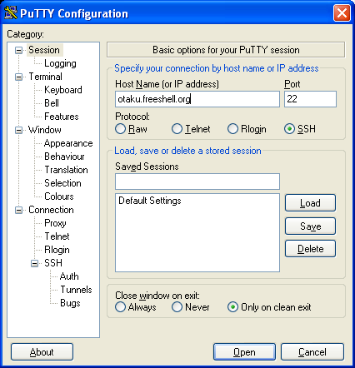

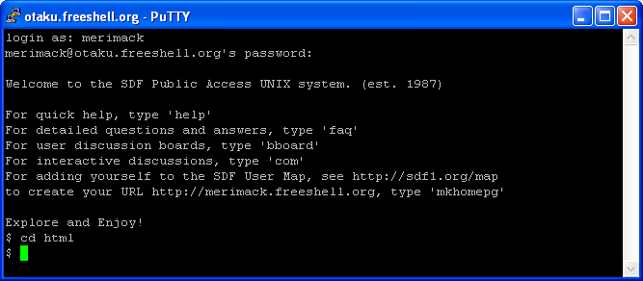

Unix commands reference
March 2010

This guide is based on a publication developed by The University of Indiana. The original document can be accessed at:

http//www.indiana.edu/~uitspubs/b017/

Abbreviations used in this pamphlet
Ctrl/x hold down control key and press x
d directory
env environment
f filename
n number
nd computer node
var variable
[y/n] yes or no
[] optional arg
... list



Web Development Certification Program

Unix is CASE SENSITIVE: cd != CD
Press RETURN at the end of each command, except those marked by an asterisk (*).

Environment Control

Command Description
cd d Change to directory d
mkdir d Create new directory d
rmdir d Remove directory d
mv f1 [f2...] d Move file f to directory d
mv d1 d2 Rename directory d1 as d2
passwd Change password
alias name1 name2 Create command alias
unalias name1 Remove command alias name1
logout End terminal session

Output, Communication, & Help
Command Description
script [f] Save terminal session to f
exit Stop saving terminal session
man name UNIX manual entry for name

Process Control
Command Description
Ctrl/c * Interrupt processes
ps Print process status stats
exit Exit from shell

Environment Status
Command Description
ls [d] [f...] List files in directory
ls -1 [f...] List files in detail
quota Display disk quota
date Print date & time
who List logged in users
whoami Display current user
pwd Print working directory
history Display recent commands

File Manipulation
Command Description
pico [f] fullscreen editor
wc f Line, word, & char count
cat f List contents of file
more f List file contents by screen
less f Display file on screen at a time
cat f1 f2 > f3 Concatenates f1 & f2 into f3
chmod mode f Change protection mode of f
cmp f1 f2 Compare two files
cp f1 f2 Copy file f1 into f2
mv f1 f2 Rename file f1 as f2
rm f Delete (remove) file f
grep ‘ptn’ f Outputs lines that match ptn
diff f1 f2 Lists file differences
head f Output beginning of f
tail f Output end of f
