ftp (file transfer protocol)

- Connecting to otaku from the PC’s command prompt:

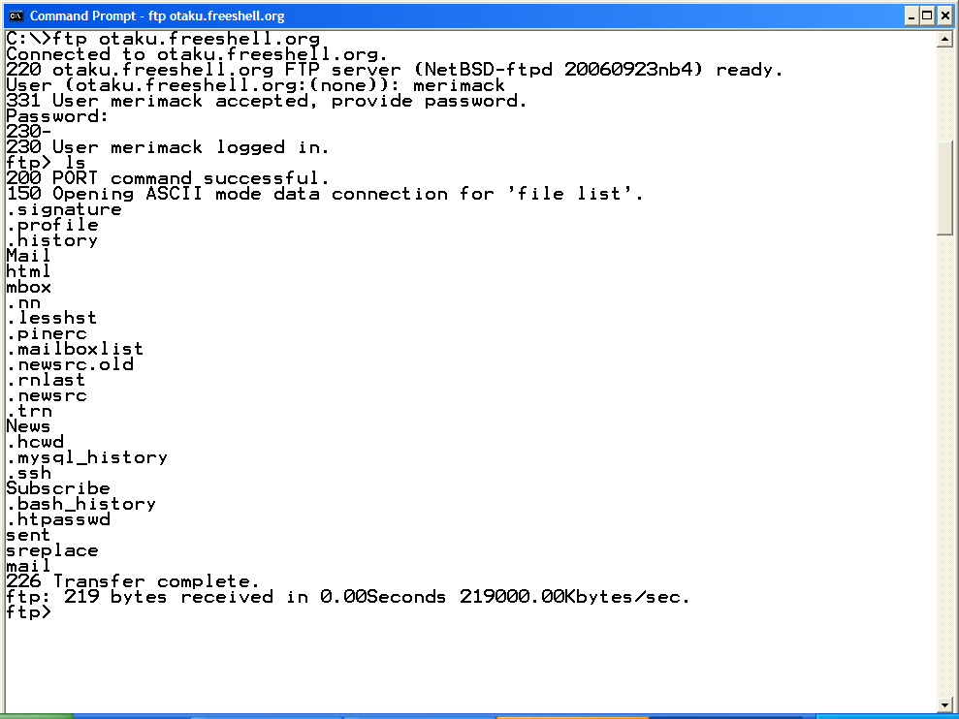

- Connecting to otaku using filezilla:

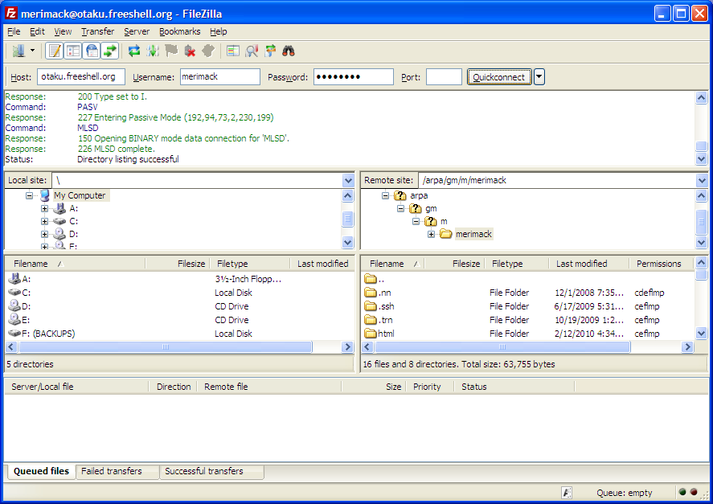

- Connecting to otaku using WS_ftp:

