Create soft glassy buttons
This tutorials shows you how to create a soft and glassy / glossy button.
This article has been written by Bernhard Stockmann using GIMP 2.3.14. It's divided into 14 steps and takes about 15 min to complete for an average user; required skill:

1 Create a new file: 150x35 px. White background. Activate the gradient-tool (L). Now choose #005a71 as primary (foreground) color. Use #00eaff as background-color. Drag the gradient from inside the upper edge of the image to the bottom: cname the layer: "Gradient". I named it "Farbverlauf" which is the german word for gradient.
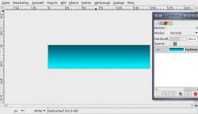
- Create a new transparent layer. Name it "Glass".
Choose white as foreground color. In the preferences of the gradient-tool use the drop-down and choose the "Foreground to Transparent"-gradient (the 4th one). Make a gradient again on this layer from top to bottom.

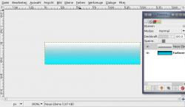
3 Take the Rectangle Selection-Tool and make a new selection starting from the bottom left as seen on the image below.
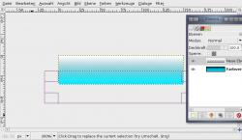
4 Cut this part by pressing DEL or (CTRL+K if you still use GIMP 2.2).
- Selection / None to deselect all.
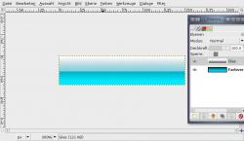
5 Next we create a small little border. Add a new layer, fill it totally black. Name it "Border" or "Rahmen" as i did in the picture.
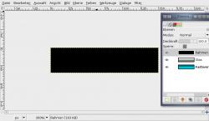
- Press CTRL+A to select all, then go to SELECTION / SHRINK: 1px.
Remove the selected part and a border should remain.

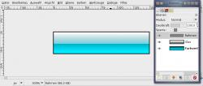
- Add a new layer again (transparent). Name it "Desaturate" (i called it "entfärben").
Now activate the Gradient-Tool again. Make sure the "Foreground to Transparent"-Option is still selected in the preferences.
Use black as foreground-color. Drag the gradient again from top to bottom, but this time a bit below the bottom edge/border of the image (into the gray space).

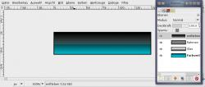
8 On the same layer do the same gradient but from right to left, again a little bit into the gray space of the left image border.
At the end only little blue to the bottom left should shine through.
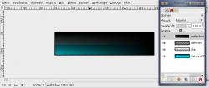
- Now press CTRL+L to view the layers dialog or go to Dialog / Layers. Set the layers mode to "Saturate" - in the image its called "Sättigung".
This mode makes all parts of the layers below gray (all parts that are filled with the black on this layer).

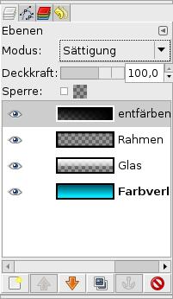
- The button should look like this now:

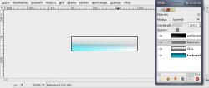

- Now take the text-tool and write any text to the layer. Move the text to the left corner.
The text layer has to be below the black "Saturate"-layer.
Activate the "Border"-layer and set the transparency of this layer to 20%.
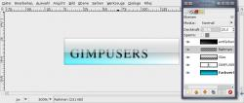
12 Now we're making the whole button a little nicer.
- Edit / Copy visible
- Edit / Paste
Then press the add layer button to get the pasted on a new layer.

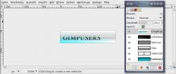
Colors / Brightness & Contrast: -20 / +30
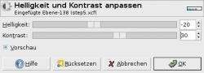
14 You're done ;) If you want to test some other colors do it the fast way ->
Add layer
Fill with your preferred color
set Layer mode to "Color".
A little tip: The buttons look best on white background with a very slight black shadow.
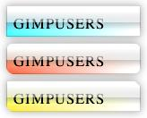

06 Jul 2007 11:10 PM
http://www.tutorialized.com/view/tutorial/Create-soft-glassy-buttons/27287

